St Andrew’s Church
Orford with Longford
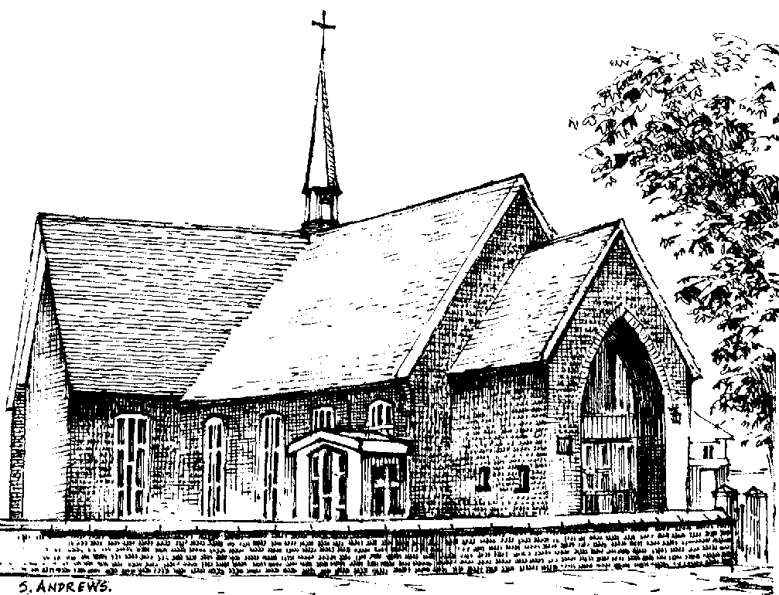

Peter Reeves

9th August 1947 - 1st November 2011

Friday 11th November 2011

Order of Service

Introduction

All: Merciful Father, hear our prayers and comfort us; renew our trust in your Son, whom you raised from the dead; strengthen our faith that all who have died in the love of Christ will share in his resurrection; who lives and reigns with you, in the unity of the Holy Spirit, one God, now and for ever. Amen

Hymn: “Abide with me”

Abide with me; fast falls the eventide:
the darkness deepens; Lord, with me abide:
when other helpers fail, and comforts flee,
help of the helpless, O abide with me.

Swift to its close ebbs out life's little day;
earth's joys grow dim, its glories pass away;
change and decay in all around I see:
O thou who changest not, abide with me.

I need thy presence every passing hour;
what but thy grace can foil the tempter's power?
Who like thyself my guide and stay can be?
Through cloud and sunshine, Lord, abide with me.

I fear no foe with thee at hand to bless;
ills have no weight, and tears no bitterness,
Where is death's sting? Where, grave, thy victory?
I triumph still, if thou abide with me.

Hold thou thy cross before my closing eyes;
shine through the gloom, and point me to the skies:
heaven's morning breaks, and earth's vain shadows flee;
in life, in death, O Lord, abide with me.

The Ministry of the Word

The Scriptural Reading (John 14. 1-6)

“Jesus said to his disciples: 'Do not let your hearts be troubled. Believe in God, believe also in me. In my Father's house there are many dwelling places. If it were not so, would I have told you that I go to prepare a place for you? And if I go and prepare a place for you, I will come again and will take you to myself, so that where I am, there you may be also. And you know the way to the place where I am going.' Thomas said to him, 'Lord, we do not know where you are going. How can we know the way?' Jesus said to him, 'I am the way, and the truth, and the life. No one comes to the Father except through me.'”

This is the word of the Lord
All: Thanks be to God

The Address

The Prayers:

Each section concludes:
Lord, in your mercy
All: hear our prayer.

After the final section:
God of mercy, entrusting into your hands all that you have made and rejoicing in our communion with all your faithful people, we make our prayers through Jesus Christ our Saviour. Amen.

The Lord’s Prayer

All: Our Father, who art in heaven, hallowed be thy name; thy kingdom come; thy will be done; on earth as it is in heaven. Give us this day our daily bread. And forgive us our trespasses, as we forgive those who trespass against us. And lead us not into temptation; but deliver us from evil. For thine is the kingdom, the power and the glory, for ever and ever. Amen
Hymn: “Guide me O thou great Redeemer”

Guide me, O thou great Redeemer,
pilgrim through this barren land;
I am weak, but thou art mighty;
hold me with thy powerful hand:
Bread of heaven, bread of heaven,
feed me now and evermore.

Open now the crystal fountain
whence the healing stream doth flow;
let the fiery cloudy pillar
lead me all my journey through;
strong deliverer, strong deliverer,
be thou still my strength and shield.

When I tread the verge of Jordan,
bid my anxious fears subside;
death of death, and hells destruction,
land me safe on Canaan's side:
songs of praises, songs and praises
I will ever give to thee.

Commendation and Farewell

All: Heavenly Father, in your Son Jesus Christ you have given us a true faith and a sure hope. Strengthen this faith and hope in us all our days, that we may live as those who believe in the communion of saints, the forgiveness of sins and the resurrection to eternal life; through Jesus Christ our Lord. Amen.

Acknowledgement: Common Worship: Pastoral Services, material from which is included in this service, is copyright © The Archbishops’ Council (2000)

